Name : Yousef Mohamed Ahmed Ragab Khalil

B.N : 1074

Date : 7/6/2021

Topic : Artificial Intelligence

Application Brief : I chose the topic of artificial intelligence because of its importance in our time, and I will talk about what is artificial intelligence, the history of research in artificial intelligence, types of artificial intelligence, problems of artificial intelligence and applications of artificial intelligence.

Artificial Intelligence Homepage
Links
- Artificial Intelligence Homepage
- What Is The Artificial Intelligence
- History Of Artificial Intelligence Research
- Types Of Artificial Intelligence
- Artificial Intelligence Problems
- Artificial Intelligence Application
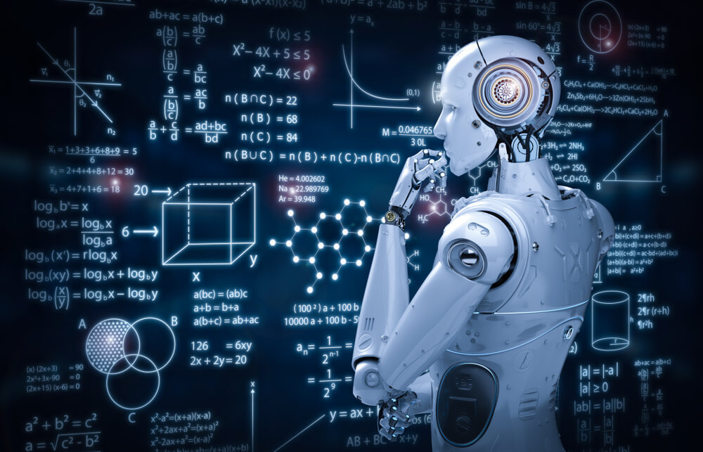
AI is concerned with the design and implementation of computer systems capable of solving problems that usually require the ability of human beings. Such problems correspond to a high complexity or to natural tasks (e.g. vision or natural language understanding). They usually cannot be solved by classical algorithmic methods. For solving them, AI programs mainly manipulate symbolic information and not only numerical data as usual in computer science. AI makes an extensive use of various kinds of knowledge about a domain of application. Therefore the problems of knowledge acquisition, representation and use are central in AI research and development. The implementation of knowledge-based systems represents one of the most active branches. An important characteristic of AI is its pluridisciplinarity. AI has strong relationships with computer science, but the development of AI projects necessitates also notions coming from logic, linguistics, cognitive sciences, etc. Besides, AI is used in a large variety of application fields: medicine, industry, bank and finance, etc

What Is The Artificial Intelligence
Links
- Artificial Intelligence Homepage
- What Is The Artificial Intelligence
- History Of Artificial Intelligence Research
- Types Of Artificial Intelligence
- Artificial Intelligence Problems
- Artificial Intelligence Application
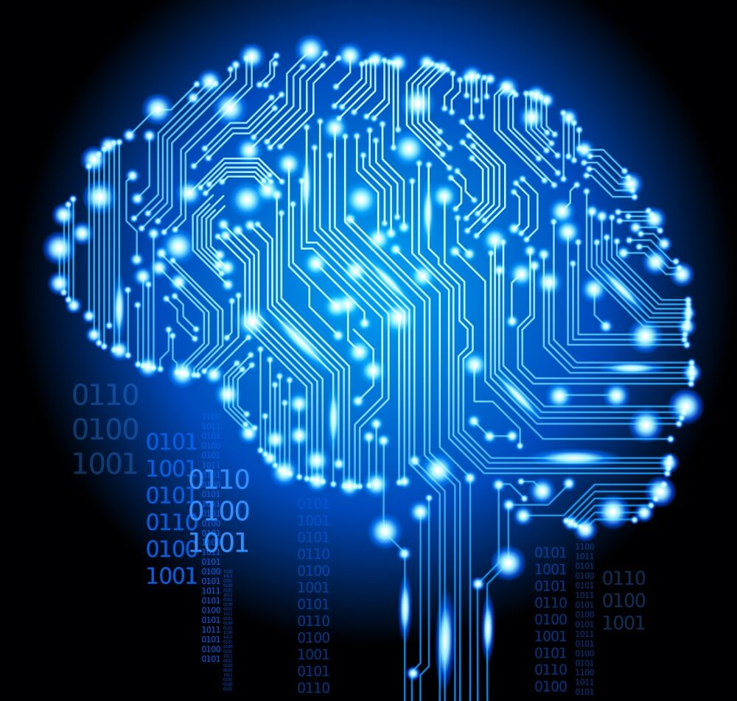 Artificial intelligence (AI) is intelligence demonstrated by machines, unlike the natural intelligence displayed by humans and animals, which involves consciousness and emotionality. The distinction between the former and the latter categories is often revealed by the acronym chosen. 'Strong' AI is usually labelled as artificial general intelligence (AGI) while attempts to emulate 'natural' intelligence have been called artificial biological intelligence (ABI). Leading AI textbooks define the field as the study of "intelligent agents": any device that perceives its environment and takes actions that maximize its chance of achieving its goals.[3] Colloquially, the term "artificial intelligence" is often used to describe machines that mimic "cognitive" functions that humans associate with the human mind, such as "learning" and "problem solving".[4] As machines become increasingly capable, tasks considered to require "intelligence" are often removed from the definition of AI, a phenomenon known as the AI effect.[5] A quip in Tesler's Theorem says "AI is whatever hasn't been done yet."[6] For instance, optical character recognition is frequently excluded from things considered to be AI,[7] having become a routine technology.[8] Modern machine capabilities generally classified as AI include successfully understanding human speech,[9] competing at the highest level in strategic game systems (such as chess and Go),[10] and also imperfect-information games like poker,[11] self-driving cars, intelligent routing in content delivery networks, and military simulations.[12] Artificial intelligence was founded as an academic discipline in 1955, and in the years since has experienced several waves of optimism,[13][14] followed by disappointment and the loss of funding (known as an "AI winter"),[15][16] followed by new approaches, success and renewed funding.[14][17] After AlphaGo defeated a professional Go player in 2015, artificial intelligence once again attracted widespread global attention.[18] For most of its history, AI research has been divided into sub-fields that often fail to communicate with each other.[19] These sub-fields are based on technical considerations, such as particular goals (e.g. "robotics" or "machine learning"),[20] the use of particular tools ("logic" or artificial neural networks), or deep philosophical differences.[23][24][25] Sub-fields have also been based on social factors (particular institutions or the work of particular researchers).[19] The traditional problems (or goals) of AI research include reasoning, knowledge representation, planning, learning, natural language processing, perception and the ability to move and manipulate objects.[20] AGI is among the field's long-term goals.[26] Approaches include statistical methods, computational intelligence, and traditional symbolic AI. Many tools are used in AI, including versions of search and mathematical optimization, artificial neural networks, and methods based on statistics, probability and economics. The AI field draws upon computer science, information engineering, mathematics, psychology, linguistics, philosophy, and many other fields. The field was founded on the assumption that human intelligence "can be so precisely described that a machine can be made to simulate it".[27] This raises philosophical arguments about the mind and the ethics of creating artificial beings endowed with human-like intelligence. These issues have been explored by myth, fiction and philosophy since antiquity.[32] Some people also consider AI to be a danger to humanity if it progresses unabated.[33][34] Others believe that AI, unlike previous technological revolutions, will create a risk of mass unemployment.[35] In the twenty-first century, AI techniques have experienced a resurgence following concurrent advances in computer power, large amounts of data, and theoretical understanding; and AI techniques have become an essential part of the technology industry, helping to solve many challenging problems in computer science, software engineering and operations research.[36][17

History Of Artificial Intelligence Research
Links
- Artificial Intelligence Homepage
- What Is The Artificial Intelligence
- History Of Artificial Intelligence Research
- Types Of Artificial Intelligence
- Artificial Intelligence Problems
- Artificial Intelligence Application
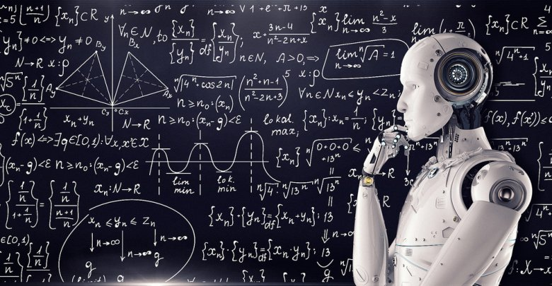 Thought-capable artificial beings appeared as storytelling devices in antiquity,[37] and have been common in fiction, as in Mary Shelley is Frankenstein or Karel Čapek is R.U.R.[38] These characters and their fates raised many of the same issues now discussed in the ethics of artificial intelligence.[32] The study of mechanical or formal reasoning began with philosophers and mathematicians in antiquity. The study of mathematical logic led directly to Alan Turing is theory of computation, which suggested that a machine, by shuffling symbols as simple as 0 and 1 could simulate any conceivable act of mathematical deduction. This insight, that digital computers can simulate any process of formal reasoning, is known as the Church–Turing thesis.[39] Along with concurrent discoveries in neurobiology, information theory and cybernetics, this led researchers to consider the possibility of building an electronic brain. Turing proposed changing the question from whether a machine was intelligent, to whether or not it is possible for machinery to show intelligent behaviour.[40] The first work that is now generally recognized as AI was McCullouch and Pitts 1943 formal design for Turing-complete artificial neurons.[41] The field of AI research was born at a workshop at Dartmouth College in 1956,[42] where the term Artificial Intelligence was coined by John McCarthy to distinguish the field from cybernetics and escape the influence of the cyberneticist Norbert Wiener.[43] Attendees Allen Newell (CMU), Herbert Simon (CMU), John McCarthy (MIT), Marvin Minsky (MIT) and Arthur Samuel (IBM) became the founders and leaders of AI research.[44] They and their students produced programs that the press described as astonishing [45] computers were learning checkers strategies (c. 1954)[46] (and by 1959 were reportedly playing better than the average human),[47] solving word problems in algebra, proving logical theorems (Logic Theorist, first run c. 1956) and speaking English.[48] By the middle of the 1960s, research in the U.S. was heavily funded by the Department of Defense[49] and laboratories had been established around the world.[50] AI is founders were optimistic about the future: Herbert Simon predicted, machines will be capable, within twenty years, of doing any work a man can do. Marvin Minsky agreed, writing, within a generation ... the problem of creating artificial intelligence will substantially be solved.[13] They failed to recognize the difficulty of some of the remaining tasks. Progress slowed and in 1974, in response to the criticism of Sir James Lighthill[51] and ongoing pressure from the US Congress to fund more productive projects, both the U.S. and British governments cut off exploratory research in AI. The next few years would later be called an AI winter [15] a period when obtaining funding for AI projects was difficult. In the early 1980s, AI research was revived by the commercial success of expert systems,[52] a form of AI program that simulated the knowledge and analytical skills of human experts. By 1985, the market for AI had reached over a billion dollars. At the same time, Japan is fifth generation computer project inspired the U.S and British governments to restore funding for academic research.[14] However, beginning with the collapse of the Lisp Machine market in 1987, AI once again fell into disrepute, and a second, longer-lasting hiatus began.[16] The development of metal–oxide–semiconductor (MOS) very-large-scale integration (VLSI), in the form of complementary MOS (CMOS) transistor technology, enabled the development of practical artificial neural network (ANN) technology in the 1980s. A landmark publication in the field was the 1989 book Analog VLSI Implementation of Neural Systems by Carver A. Mead and Mohammed Ismail.[53] In the late 1990s and early 21st century, AI began to be used for logistics, data mining, medical diagnosis and other areas.[36] The success was due to increasing computational power (see Moore is law and transistor count), greater emphasis on solving specific problems, new ties between AI and other fields (such as statistics, economics and mathematics), and a commitment by researchers to mathematical methods and scientific standards.[54] Deep Blue became the first computer chess-playing system to beat a reigning world chess champion, Garry Kasparov, on 11 May 1997.[55]

Types Of Artificial Intelligence
Links
- Artificial Intelligence Homepage
- What Is The Artificial Intelligence
- History Of Artificial Intelligence Research
- Types Of Artificial Intelligence
- Artificial Intelligence Problems
- Artificial Intelligence Application
Types of Artificial Intelligence: Artificial Intelligence can be divided in various types, there are mainly two types of main categorization which are based on capabilities and based on functionally of AI. Following is flow diagram which explain the types of AI. 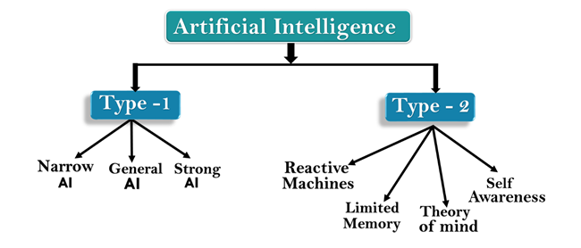 AI type-1: Based on Capabilities 1. Weak AI or Narrow AI: Narrow AI is a type of AI which is able to perform a dedicated task with intelligence.The most common and currently available AI is Narrow AI in the world of Artificial Intelligence. Narrow AI cannot perform beyond its field or limitations, as it is only trained for one specific task. Hence it is also termed as weak AI. Narrow AI can fail in unpredictable ways if it goes beyond its limits. Apple Siriis a good example of Narrow AI, but it operates with a limited pre-defined range of functions. IBM's Watson supercomputer also comes under Narrow AI, as it uses an Expert system approach combined with Machine learning and natural language processing. Some Examples of Narrow AI are playing chess, purchasing suggestions on e-commerce site, self-driving cars, speech recognition, and image recognition. 2. General AI: General AI is a type of intelligence which could perform any intellectual task with efficiency like a human. The idea behind the general AI to make such a system which could be smarter and think like a human by its own. Currently, there is no such system exist which could come under general AI and can perform any task as perfect as a human. The worldwide researchers are now focused on developing machines with General AI. As systems with general AI are still under research, and it will take lots of efforts and time to develop such systems. 3. Super AI: Super AI is a level of Intelligence of Systems at which machines could surpass human intelligence, and can perform any task better than human with cognitive properties. It is an outcome of general AI. Some key characteristics of strong AI include capability include the ability to think, to reason,solve the puzzle, make judgments, plan, learn, and communicate by its own. Super AI is still a hypothetical concept of Artificial Intelligence. Development of such systems in real is still world changing task.
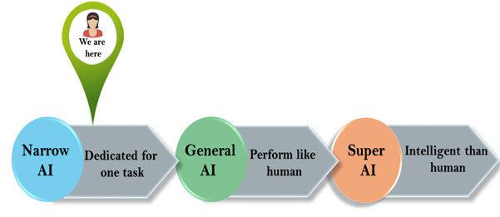 Artificial Intelligence type-2: Based on functionality 1. Reactive Machines Purely reactive machines are the most basic types of Artificial Intelligence. Such AI systems do not store memories or past experiences for future actions. These machines only focus on current scenarios and react on it as per possible best action. IBM's Deep Blue system is an example of reactive machines. Google's AlphaGo is also an example of reactive machines. 2. Limited Memory Limited memory machines can store past experiences or some data for a short period of time. These machines can use stored data for a limited time period only. Self-driving cars are one of the best examples of Limited Memory systems. These cars can store recent speed of nearby cars, the distance of other cars, speed limit, and other information to navigate the road. 3. Theory of Mind Theory of Mind AI should understand the human emotions, people, beliefs, and be able to interact socially like humans. This type of AI machines are still not developed, but researchers are making lots of efforts and improvement for developing such AI machines. 4. Self-Awareness Self-awareness AI is the future of Artificial Intelligence. These machines will be super intelligent, and will have their own consciousness, sentiments, and self-awareness. These machines will be smarter than human mind. Self-Awareness AI does not exist in reality still and it is a hypothetical concept.

Artificial Intelligence Problems
Links
- Artificial Intelligence Homepage
- What Is The Artificial Intelligence
- History Of Artificial Intelligence Research
- Types Of Artificial Intelligence
- Artificial Intelligence Problems
- Artificial Intelligence Application
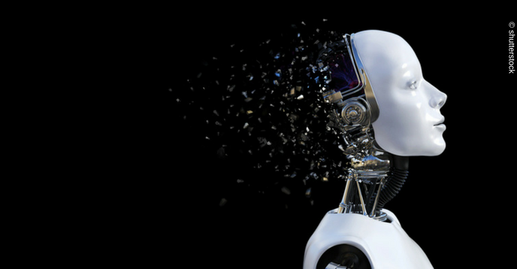 There is no doubt that the field of artificial intelligence has great benefits that serve humanity and can be used to greatly facilitate life, but it has its negatives and many problems that cannot be overlooked. The problems of artificial intelligence are represented in the following points: No place for emotions: All human concepts of conscience, compassion, and the collective spirit will be gone, meaning that machines can perform many tasks without having ties with humans, so that artificial intelligence cannot replace human relationships. Unemployment: A person cannot compete with a machine in terms of efficiency, and therefore machines will replace humans in various practical fields, which will increase the unemployment rate. High cost: Working in this field requires a lot of money, whether in the processes of manufacturing machines, programming and repairing them. Data loss: Despite the huge memory that such machines may have, but there will be no connection between this information when storing and retrieval as humans do, and some damage to the machine can lead to the loss of all data stored on it. Monotony: These machines cannot go out of the ordinary and create something new as humans do, so their uses in the scientific and technical fields remain without benefit in the fields of arts. Wrong use: Like many inventions invented by scientists for important purposes, but when they fell into the wrong hands, they were exploited for wars, and the exploitation of artificial intelligence for non-scientific purposes that do not serve society constitutes a real threat. Despite the problems of artificial intelligence, it represents the future, provided that it is used correctly and to serve society only, and a balance is made between the work of machines and the work of humans in order to reach the maximum benefit.

Artificial Intelligence Application
Links
- Artificial Intelligence Homepage
- What Is The Artificial Intelligence
- History Of Artificial Intelligence Research
- Types Of Artificial Intelligence
- Artificial Intelligence Problems
- Artificial Intelligence Application
 AI is relevant to any intellectual task.[192] Modern artificial intelligence techniques are pervasive[193] and are too numerous to list here. Frequently, when a technique reaches mainstream use, it is no longer considered artificial intelligence; this phenomenon is described as the AI effect.[194] High-profile examples of AI include autonomous vehicles (such as drones and self-driving cars), medical diagnosis, creating art (such as poetry), proving mathematical theorems, playing games (such as Chess or Go), search engines (such as Google Search), online assistants (such as Siri), image recognition in photographs, spam filtering, predicting flight delays,[195] prediction of judicial decisions,[196] targeting online advertisements, [192][197][198] and energy storage[199] With social media sites overtaking TV as a source for news for young people and news organizations increasingly reliant on social media platforms for generating distribution,[200] major publishers now use artificial intelligence (AI) technology to post stories more effectively and generate higher volumes of traffic.[201] AI can also produce Deepfakes, a content-altering technology. ZDNet reports, "It presents something that did not actually occur," Though 88% of Americans believe Deepfakes can cause more harm than good, only 47% of them believe they can be targeted. The boom of election year also opens public discourse to threats of videos of falsified politician media.[202]
Source Code :
<!DOCTYPE html>
<html>
<body>
<head>
<title>Artificial Intelligence Homepage</title>
</head>
<h1>Artificial Intelligence Homepage</h1>
<h2>Links</h2>
<ul>
<li> <a href="yousefproject.html">Artificial Intelligence Homepage</a>
</li>
<li> <a href="intelligences.html" >What Is The Artificial Intelligence</a>
</li>
<li> <a href="research.html">History Of Artificial Intelligence Research</a>
</li>
<li> <a href="intelligence.html">Types Of Artificial Intelligence</a>
</li>
<li> <a href="problem.html">Artificial Intelligence Problems</a>
</li>
<li> <a href="app.html">Artificial Intelligence Application</a>
</li>
</ul>
</body>

</html>

